SWE20001 – Development Project 1: Tools and Practices

Team Report For Week (6)

Duy Phuong Nguyen (101204984)

Lab: Friday 2:30pm

Tutor: Huai Liu

Team number: 3

Henry Tran 102075482

Edward Knight 102700043

Duy Phuong Nguyen 101204984

# Review meeting minute

1. **Product Review**

We were able to convert and build the battleship program however due to some functions missing from the SwinGame library there were new bugs that were introduced. The text for the main menu, winning and losing screen, no longer works.

For documentation, we were able to analyse the code in week 4, and decide what code does what, this analysis of the code such as which part of the code does what. This analysis was uploaded to the github wiki, and in week 5 this analysis was used to help write documentation for the code which required extra documentation.

The following things were discussed with the product owner:

* Bugs that were found when converting the code from VB to C#
* Possible features that could be implemented to the program

1. **Process Retrospective**

The conversion and the build worked well for the most part in the last iteration. There were some bugs that were introduced which were added to the product backlog to be fixed in the next iteration. Validation and documentation were fairly straightforward tasks and were done well.

Something that could be improved on is using Trello to track the progress of task completion. Otherwise there wasn’t much else to improve on this week since the only things that we did were conversion of the code, validation and documentation.

1. **Individual contribution**

* Henry - Created Process retrospective, product backlog.
* Edward - Prepared the Trello board for Iteration 2, product review - documentation, Provided some features in product backlog.
* Duy Phuong - “What could be improved in the next iteration”, Checked our group source code with Mono app, which is posted in week 6 modules, Mentioned all the errors in our code from last week iteration.

# Meeting Agenda

|  |
| --- |
| Meeting Agenda for [Project Group 3]  Date/Location: 12:30pm 26/4/20 over Discord voice call  Information Updates/Reminders  =============================  * Last week was about converting and documenting the code  * This week we will use a DAD process over two weeks to fix bugs and  extend the project. (No bug fixing or extensions yet!)  * Help from an external consultant can be provided to help get the  code converted and working if that was not done. (Ask our tutor.)  * Everyone should have used toggl.com to track their time last  week. Also track time on tasks this week with Toggl.  * Tutor must be added to GitHub and Trello.  * Discord channel will be used to show the changes in the Trello board  during the iteration  * The Programming Help Desk ATC620 is not available during covid-19 period.  Decisions Needed  ================  *    Who would be responsible for each role in the weekly task  *    How the battleship project would be split for completion  *    Complete all the tasks using the DAD process.  General Items  =============  *     The Trello board needs to be updated ready for the planned  iteration. In particular columns for project backlog and iteration  backlog will be needed.  *     Create and link the team slack so that we can be notified and have  a nice record of the Trello updates.  *     The project backlog needs to be created and gets the product owner’s  approval. Use the existing bugs and features we have documented, and  convert to the required format. The project backlog has to be entered  into Trello (today).  *     Project backlog tasks need to be prioritised and their time  estimated. (Today)  *     The new iteration backlog needs to be pre-selected ready for  discussion and approval with the product owner. (Today)  *     Once the iteration has started, hold a daily stand-up. (Can happen  today or during the week) |

# Meeting minutes

**Decision:**

*    Who would be responsible for each role in the weekly task

*    How the battleship project would be split for completion

*    Complete all the tasks using the DAD process.

**Actions:**

* The battleship was decided to be our group project. There is a Dice Roller project which based on Java but we think C# is less complex.
* The roles for the project are:
  + Henry Tran - Team member
  + Edward Knight - Team member
  + Duy Phuong Nguyen - Team Leader.
  + Our tutor act as the product owner
* We completed the group report together as a group during the meeting and the group leader will finalize, checking and submit the report to doubtfire.
* Update Trello board ready for DAD iteration.

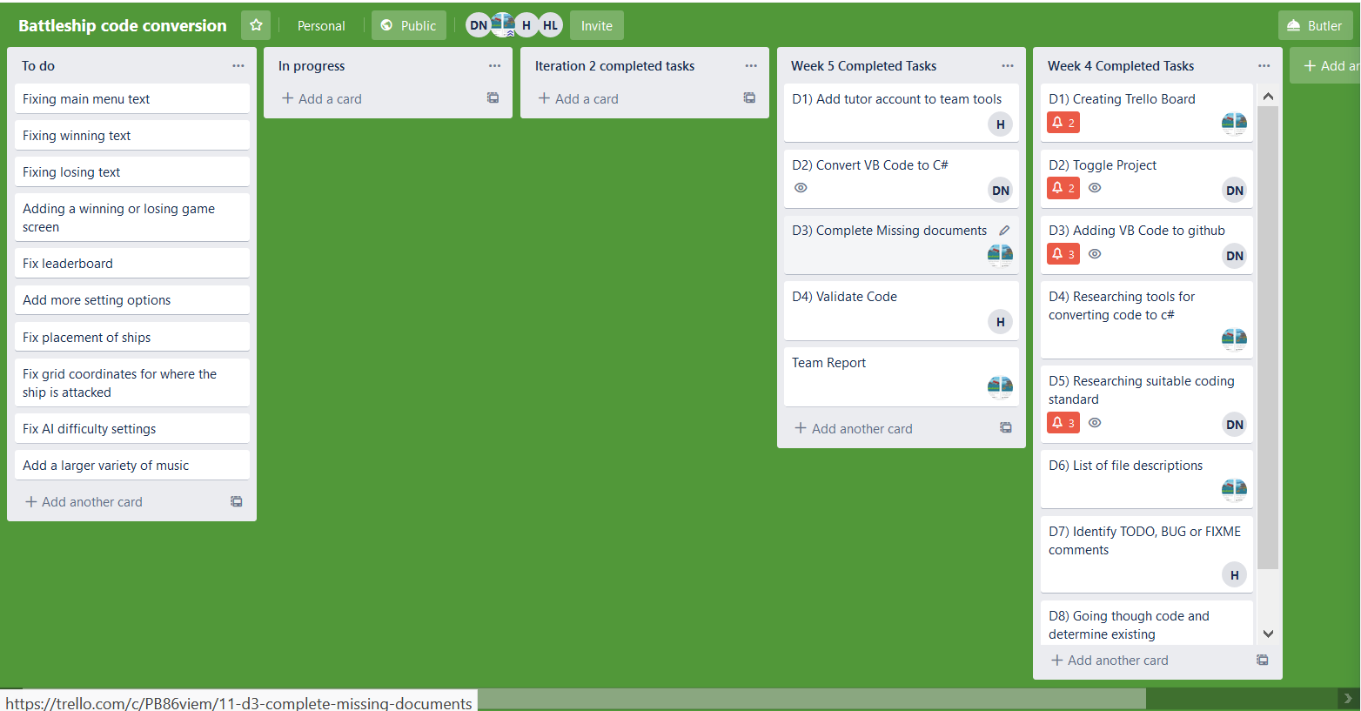

* Create an Iteration backlog so we can split the work and fix all the bugs of this project during week 6.

**Iteration Backlog for Week 6**

|  |  |
| --- | --- |
| Tasks | Member Responsible |
| Fixing main menu text | Henry |
| Fixing winning text | Henry |
| Fixing losing text | Henry |
| Fix leaderboard | Phuong |
| Fix AI difficulty settings | Phuong |
| Fix placement of ships | Edward |
| Fix grid coordinates for where the ship is attacked | Edward |

* Planning for the battleship project using a product backlog.

**Product Backlog**

|  |  |  |  |
| --- | --- | --- | --- |
| **Tasks** | **Type** | **Due Date** | **Priority (1-5)**  **(1 highest)** |
| Fixing main menu text | Bug | 6/5/20 | 1 |
| Fixing winning text | Bug | 6/5/20 | 1 |
| Fixing losing text | Bug | 6/5/20 | 1 |
| Adding a winning or losing game screen | Feature | 13/5/20 | 2 |
| Fix leader board | Bug | 6/5/20 | 1 |
| Add more setting options | Feature | 13/5/20 | 3 |
| Fix placement of ships | Bug | 6/5/20 | 1 |
| Fix grid coordinates for where the ship is attacked | Bug | 6/5/20 | 1 |
| Fix AI difficulty settings | Bug | 6/5/20 | 1 |
| Add more music | Feature | 13/5/20 | 3 |

## 4. Work done by team member during the week

* Edward fixed his tasks in Iteration Backlog, which are: Fix placement of ships and Fix grid coordinates for where the ship is attacked

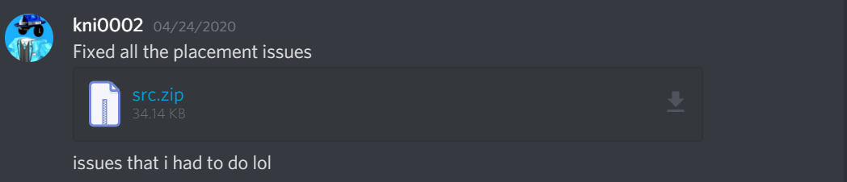

* Henry and Phuong are working on their tasks. The Trello board is updated (28th of April).

